[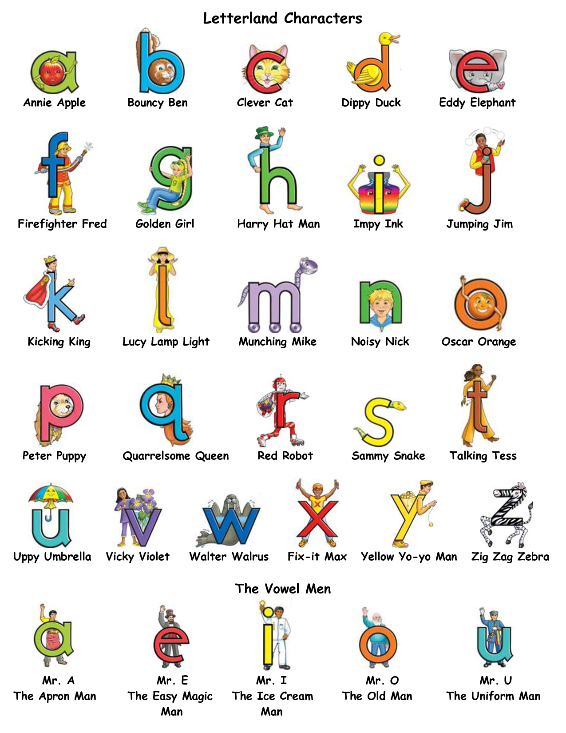](http://www.google.com/url?sa=i&source=images&cd=&cad=rja&docid=01VTWGHkLRHN-M&tbnid=DhY3mWCOXigGKM:&ved=0CAgQjRwwAA&url=http://www.docstoc.com/docs/115170349/Letterland-Characters-chart-September-2011&ei=d7i0UdHKAcfH0QGRtICgCQ&psig=AFQjCNHav6cyF7KfGzgBxh8SjwiHfBHjhQ&ust=1370884599066161)